Board Meeting ……………………………………………………..
The Minutes Passed with corrections.
PRESIDENT’S REPORT, ADDENDUM: LYN BELISLE KURTIN
SAALM will loan two paintings from the Permanent Collection to the Stark Gallery at Texas A&M at the request of William Reaves, who would like the following works:
1. Robert Onderdonk, Still Life with Fish,
2. Ella Mewhinney, Still Life with Flowers
The exhibition, entitled "Evocative Objects: Still Life Painting in Texas" is a part of a new series on Texas art. It is currently scheduled from August 6 - October 4, 2020. There will be an accompanying museum exhibition catalogue. The Stark Gallery is a public, non-profit, fully-certified museum, and complies with all appropriate museum exhibition standards. Loaned items will be fully insured by the university, and transported to and from site by museum staff.

TREASURER’S REPORT: LINDA KEEN
The SAALM bookkeeping entry work is caught up and I want to wait till 3-31 to create the EOM Report. I THANK Bill Kurtin for keeping our bills paid in the meantime.
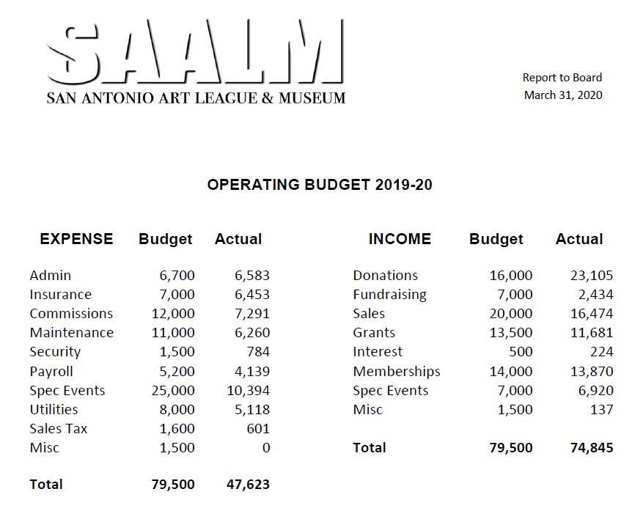

MEMBERSHIP REPORT: DONA WALSTON
There are 408 members on our membership list. Membership renewal letters should go out in late April.
CONSTRUCTION REPORT: DR. BILL KURTIN
The remainder of the project to move artwork to the storage annex and renovate the old vault space is on hold for now.

The planned series of steps to complete the project are as follows:

1) Move the artwork from the hidden closet by the Member’s Gallery to the annex.
2) Cull useless records from the filing cabinets and storage unit in the old vault.
3) Move the filing cabinets into the hidden closet upstairs. There is room in the hidden closet for the wooden storage unit as well, but we may no longer need that piece of furniture.
4) Determine specific details for renovation of the old vault.
5) Begin renovation work.
6) Move remainder of artwork stored in upstairs kitchen, bathroom, and folding door closet to annex.

As of this date we are still waiting for the replacement smoke alarm for the fire protection system.

EDUCATON REPORT: DR. MARY BETH SWOFFORD
The Collegiate Exhibit was uninstalled early on March 21 because of the closure of SAALM. Many thanks to Lyn Belisle, Bill Kurtin, Brian St. John, and Miguel Cortinas. In the interest of student and committee members’ safety, faculty members were asked to pick up student work from their respective universities. Faculty from UIW, St. Mary’s and Trinity picked up student work. Student work not picked was stored in the Semmes.
Respectfully submitted
Mary Beth Swofford, Ph.D.
Chair, Education Committee.

ARTIST OF THE YEAR 2020 Billy Keen, Committee Chair
Report to Board March 31, 2020
Since I last reported to you, Ansen Seale and I have met virtually and made successful progress toward this fall’s show. He has created a List of Works to exhibit in retrospect. We agree that to chronicle development from the early works leading up to current masterpieces will create a visual banquet for the eyes.
Catalog printing is on schedule. Ansen has contacted Luis Puron, Director of the Rockport Center for the Arts, who plans to contribute a written statement for the catalog. As in 2016, Puron is planning a field trip bringing artists from Rockport to the Artist of the Year Opening.
Ansen continues to be excited about September’s Artist of The Year 2020 Opening and the year ahead. The Art League’s recognition of Seale’s cutting edge excellence in artistic photography promises to offer a feast for the eyes beginning Sunday, Sept 13th, 3-5 PM.
All this talk about food makes me hungry. A special thank you in advance to Nancy Gerfers, incoming VP Hospitality, for we look forward to refreshments at the Opening! I thank Lyn Belisle Kurtin for her support, as well as the other committee members: Susan Brumfield Farris, Steven G. Smith, Nancy Kempf, Kathleen Garrison, Gordon West, and Linda Keen.

ARTIST OF THE YEAR 2021: Kathleen Garrison, Committee Chair

My committee nominated 12 artists to be considered for the honor of Artist of the Year 2021. Dona Walston graciously helped this technically challenged board member by sending out the invitations to the 12 and only 2 have declined.
SOCIAL MEDIA: PETER SZARMACH

I've kept up my photo-a-day posting on FB and Instagram. On the board report front, not a lot to report on, just the posting of our closing. Wondering if we would entertain a virtual "preview" of the 90th Annual Exhibition online if this pandemic keeps us closed longer than we might expect.

90TH ANNUAL JURIED EXHIBIT: SONJA HARRIS

90th SA Art League Juried Exhibition Report
Board (email) Meeting
April 1, 2020

90th SA Art League Juried Exhibition Report: The 90th Juried Show is postponed until further notice. As it stands most of Texas counties are closed until the end of April. We will discuss at the appropriate time when non-essential businesses are opened to the public.

Sonja Harris
Chair

